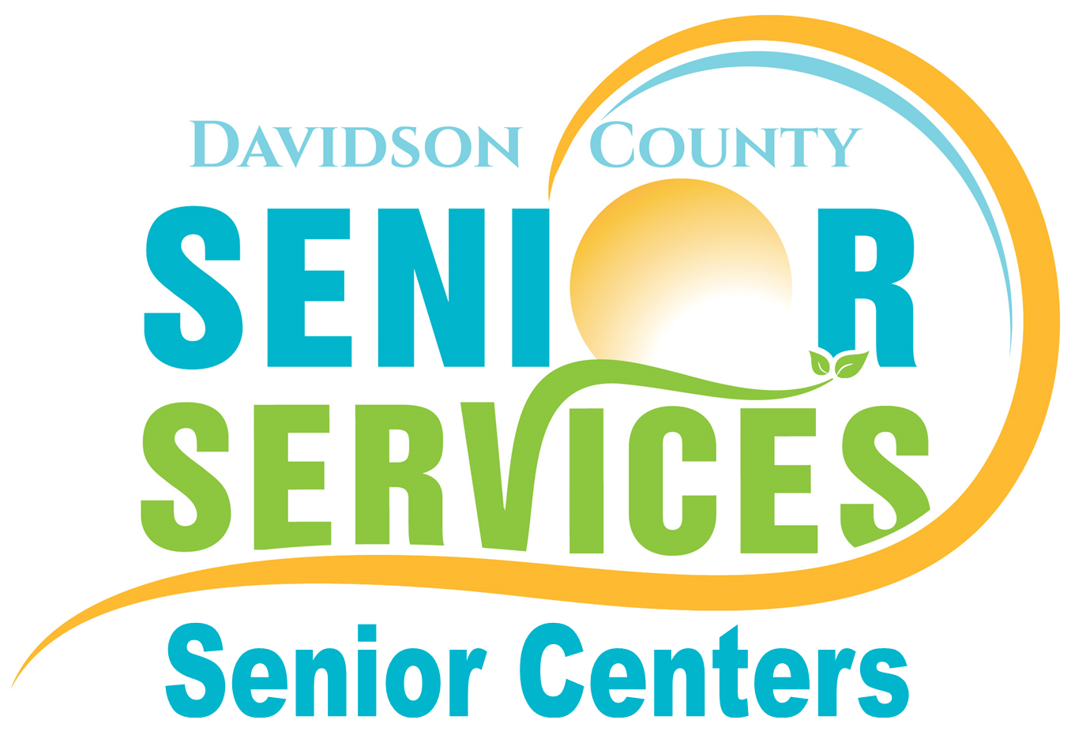

DAVIDSON COUNTY DEPARTMENT OF SENIOR SERVICES
PROGRAM PARTICIPATION EVALUATION

Please take a few minutes to complete this evaluation. Your comments will help us to improve our service and monitor the quality of our programs. Thank you.
Course Information

Date of Program: ___________________ Instructor: __________________________________
Title of Program:___________________________________________________________________
Please select your response.
Class Evaluation | Strongly Agree | Agree | Neutral | Disagree | Strongly Disagree
The material covered was beneficial
The subject matter was organized
Handouts were helpful (if applicable)
Gained knowledge of the subject presented
Class duration was appropriate
I would recommend to someone else
Instructor / Speaker Evaluation | Strongly Agree | Agree | Neutral | Disagree | Strongly Disagree
Speaker or instructor prepared and well organized
Demonstrated knowledge of material presented
Speaker or instructor answered my questions
The speaker or instructor was easy to understand
I would attend another program lead by this speaker or instructor
Facility and Staff Evaluation | Strongly Agree | Agree | Neutral | Disagree | Strongly Disagree
The facility provided a good climate for learning
Facility clean and neat
Facility staff friendly and helpful
Additional Comments:
What was your favorite aspect of the program? __________________________________________
________________________________________________________________________________
What can we do to improve the program? ______________________________________________
________________________________________________________________________________
Please give any suggestions you might have for future classes, speakers, activities, etc.
________________________________________________________________________________
________________________________________________________________________________
How did you hear about the program? _________________________________________________

