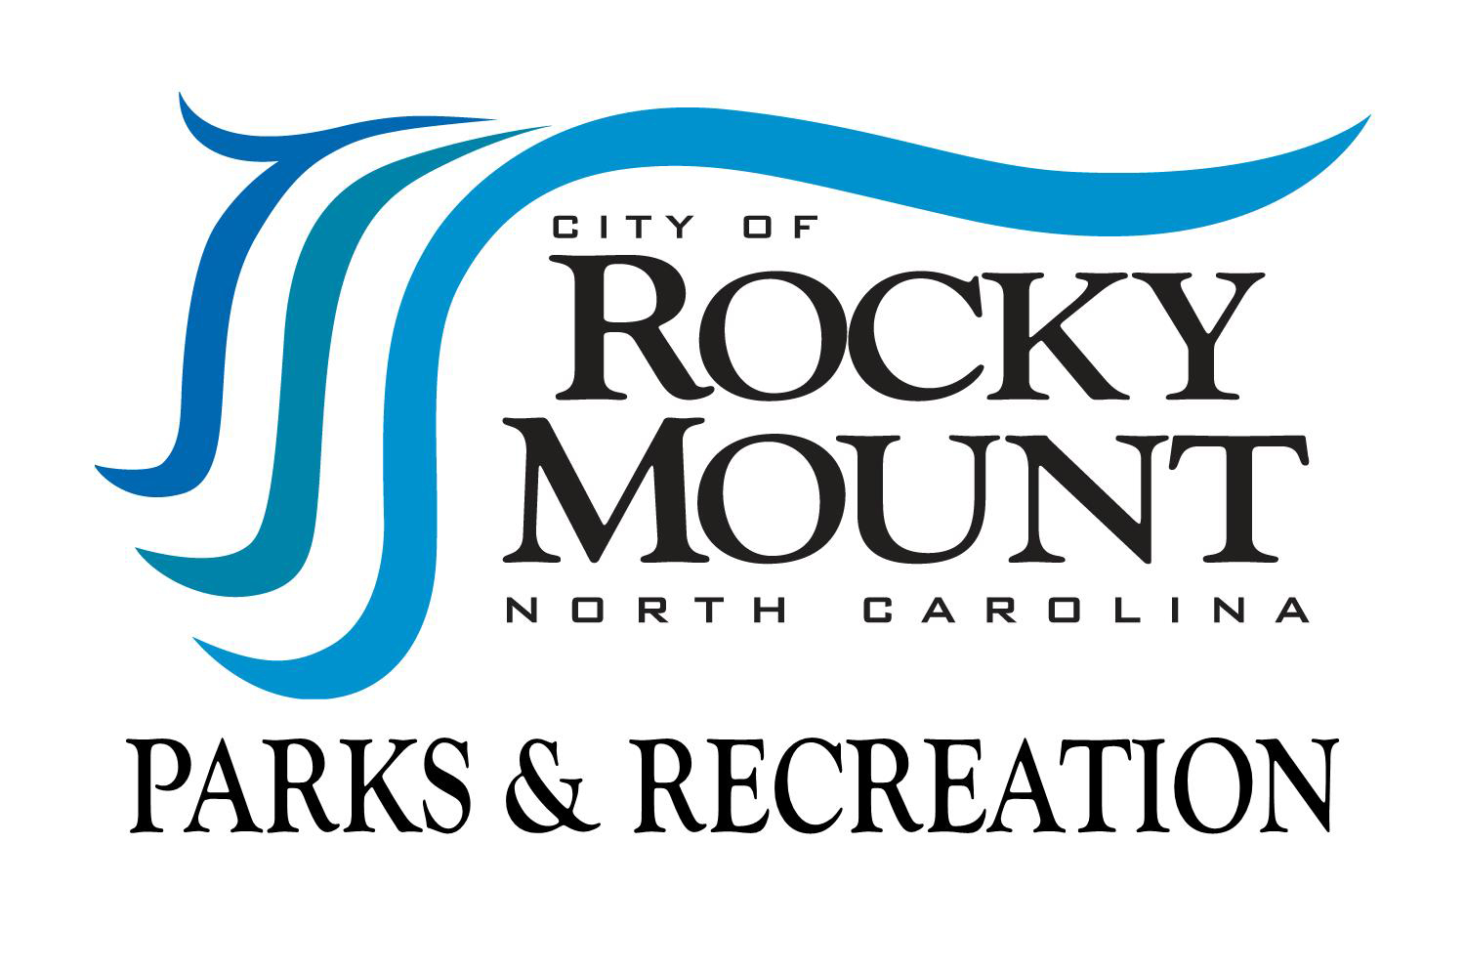
City of Rocky Mount
Parks & Recreation Department
Division of Senior Programs/Senior Center
Evaluation Plan

Introduction:

Rocky Mount Senior Center recognizes the value of evaluating its operations, programs, activities and services on a regular basis as a catalyst for change, growth, and improvement. Evaluation is an essential component of the overall planning process, and should be completed in all areas on a regular basis.

A variety of evaluation measures involving staff (city, department and division), members of the governing body (mayor and city council), volunteers, interns, participants and clients, family members, and outside resources shall be used in the process.

Areas of Evaluation:

Operations, programs, activities and services can be evaluated to examine the extent in which they:
- Meet community needs
- Address the division’s mission and strategic plan
- Are consistent with division and facility policy & procedure
- Achieve stated program objectives
- Provide for participant needs and satisfaction
- Provide for the safety of participants, staff and volunteers
- Are adequate for the demand
- Are accessible
- Do not unnecessarily duplicate an existing program or service
- Are fiscally based
- Are effectively administered
- Are effectively marketed
- Have quality and effectiveness
- Enhance the visibility and image of the Center

Information Collection Methods:

The type of evaluation (including use of computer technology) for a certain operation, program, or service shall depend on what information is needed and how is will be used. Various ways of collecting data can be used when needed and can include one of the following (this is not an all inclusive list):
- Collection of quantitative program measurements
- Satisfaction questionnaires
- Surveys and checklists
- Personal Interviews
- Personal Observations
- Focus groups
- Presentations with Q and A’s/Feedback
- Suggestion box or comment board
- Case Study Reviews

In addition, the division shall seek to use various forms of outcome based evaluations when necessary. These methods can include the following:
- Self-reporting
- Pre and Post test
- Logic models

Scheduling of Evaluations:

- Accreditation Self-Assessments and Accreditation Reviews will be completed on a five-year cycle.

- Area Agency on Aging monitoring will be completed on a cycle consistent with service standards for those programs and services being monitored.

- Evaluations and inspections from licensing and certifying agencies will be completed on a cycle consistent with regulations for those areas.

- Division staff will schedule certain areas of operation and programs, activities and services to be evaluated each year in accordance with the development of the annual action plans.

- Staff members and interns will be assigned areas to evaluate based on priority and need.

- Programs with scheduled starting and ending dates will have an evaluation component automatically included.

Results of Evaluations:

Information resulting from evaluations will be made available to staff, volunteers, funding sources, participants, and the general public and shall be used in the planning process to enhance the overall effectiveness of division programs and operations.

