Volunteer Handbook

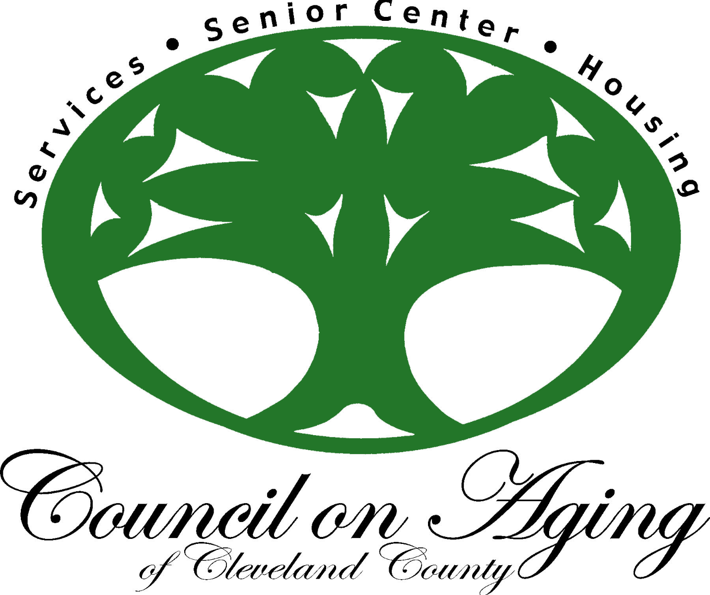

Neal Senior Center

100 TR Harris Drive

Shelby, NC 28150

Index

1. Introduction
2. Get to know the Neal Senior Center Staff
3. Senior Center Vision, Mission, Purpose & Goal
4. Policies and Procedures
5. Volunteer General Rules
6. Volunteer Code of Ethics/Agreement

**I. Introduction**

This handbook is designed to be used by all volunteers, student field workers and others who wish to gain valuable experience while working at the Neal Senior Center.

This policy/procedure handbook contains training material put together so that you, the volunteer, will feel more confident and comfortable as you meet and serve participants at the Senior Center.

The Senior Center is run by a skeleton staff. Volunteers provide instruction in many of the classes offered; assist in the daily operating functions such as office work, kitchen help, driving, decorating, bookkeeping and maintenance as well as numerous other duties as “unpaid” staff. Volunteers are the **heartbeat** of the Senior Center. We seek dependable, cheerful and willing volunteers who would like to be part of the overall program.

The Council on Aging/Neal Senior Center is a private, non-profit, 501(c) (3) organization and consists of four (4) departments.

II. Get to know the Neal Senior Center Staff

# **Administration**

# Council on Aging/Executive Director - Paulette Putnam

Administrative Assistant/Finance – Teresia Ladd

Secretary – Mary Hamrick

Assistant Bookkeeper – Jeannie Boyd

# **Senior Center’s Activities, Events & Health Promotions**

Programs Director – Daniel Dedmon

Volunteer Coordinator – Lori Livingston

Housekeeping – Stephanie Baxter-Robbs

Title V – Janie Henderson

# **Service Department**

Outreach Coordinator – Katherine Cobb

Nutrition Coordinator – Heather Ledbetter

Title V – Rita Conte

Site Manager - Lawndale– Laura Sturgis

Site Manager – West Warren – Vicki Love

Site Manager – Kings Mountain - Guynetha Warren

# **Housing Department**

Housing Director/Rental Coordinator **–** Linda Geter

Service Coordinator – Pam Cook

Site Manager – Deborah Toney

Maintenance – Brian Edwards

# **Food Service**

Food Service Director – Greg Ager

Congregate Meal/Cook – Namon Carlton

Meals Assistant & Delivery – Beth Phillips

Kitchen Custodian – Clarence Hambrick

Kitchen Aid – Title V – Becky Nanny

Kitchen Aid – Title V – Brenda Mosley

Kitchen Aid – Title V – Louise Strong

**III. VISION STATEMENT:**

Quality of Life and Independent Living…Throughout the Lifespan

**MISSION:**

To maintain the Senior Center as a focal point promoting aging as a normal process, opening doors that improve the quality of life of older adults in Cleveland County.

**PURPOSE:**

To provide a Senior Center facility and programs developed and carried out for the benefit of older adults in Cleveland County. In doing so, the Council on Aging shall assist, promote and encourage all groups, persons or organizations concerned with the well-being of older adults 50 and above. It shall also provide the volunteer services required to accomplish these purposes.

**GOAL:**

The Council on Aging/Senior Center of Cleveland County is designed to offer a broad range of services and activities to meet the needs of adults 50 and above. These needs are to include:

1. Social and Recreational
2. Educational
3. Cultural
4. Emotional
5. Physical
6. Economical

These needs are then developed into activity programs designed to enhance the quality of life and activities that are meaningful to all participants at the Senior Center and other locations in Cleveland County. The ultimate goal is to provide adequate recreational services which teach skills for leisure use, offers insurance against loneliness, gives opportunity to maintain or renew self-respect, gives opportunity to learn ways of improving one’s health and teaches the older adult that they still have a significant voice in the affairs of the community. Also, the Center must nurture, foster and encourage independence and self-direction.

You as a volunteer, are the **vital** part of the Senior Center. You are the ones that make it possible to achieve the Senior Center goals.

**IV. POLICIES AND PROCEDURES FOR VOLUNTEERS**

1. The Senior Center shall assign one staff member to be responsible for the development and management of a volunteer program in coordination with the Senior Center staff and according to the standards set forth by the National Council on Aging (NCOA).
2. Senior Center volunteers may be any age, however, if the volunteer is not 12 years of age or above, they may be asked to be accompanied by an adult.
3. Volunteers on duty immediately before, during or after lunch will receive a dollar ($1.00) discount on the cost of a full meal served in the dining room.
4. A volunteer whose performance does not meet the required standards of the Senior Center operations may be dismissed or change their assignment. If the volunteer wishes to grieve the termination/change, he/she may request a hearing with the appropriate Advisory Council/COA Ambassadors. They will make a recommendation of action to the appropriate Director.
5. The Senior Center shall hold a minimum of one formal recognition event per year for all volunteers. All volunteers with one-hour credit and up will be recognized.

* All volunteers with one-hour credit will be recognized with a certificate.
* The first year with 300 hours of credit will receive a Senior Center pin.
* The second year with 300 hours will receive a Senior Center Volunteer Name Tag and name will be added to Volunteer Excellence plaque.
* 10 years and 20 years of volunteering, you will receive a 10/20 year pin and name on the 10/20 year plaque.

**V. VOLUNTEER GENERAL RULES**

1. Record the number of hours you work in your file folder on the day that you worked. If not able, record worked hours and record at the soonest possible date.
2. Greet and introduce yourself to the participants, make them feel welcome.
3. Always be neat and well groomed. Dress according to the job.
4. If you are injured while working, report the incident to the supervisor immediately.
5. If you cannot come to work on your assigned day, please call the volunteer coordinator to let him/her know. If you are an instructor, inform the Senior Center Director or Program Coordinator and students of any changes in class schedule and cancellations.
6. Be aware of new participants, encouraging and stressing to them the importance of filling in information on activity sheets.
7. Confidentiality is very important; DO NOT disclose any information you may receive while volunteering. Commitment to our clients’ rights of privacy by protecting all confidential information will be required at all times. Names of those we serve are not to be referenced outside of the Neal Senior Center, except when collaborating with other service agencies in the best interest of the client.
8. Volunteers encourage even the smallest gesture of generosity… whether a gift, time, or words of kindness, but DO NOT personally accept money or gifts from the person served. This would lead to complicated relationships and expectations. Encourage donations to The Neal Senior Center.

**VI. Volunteer Code of Ethics/Agreement**

As a volunteer, I am representing the Council on Aging/Neal Senior Center as if I were a regular staff member and am under the same conduct and regulations:

1. I am willing to assume the responsibilities involved, be reliable, be on time.
2. I am willing to follow the instructions of the leader of the group, carry out the program as planned and ask questions if I don’t understand.
3. I am interested in others; let everyone I work with feel important.
4. I will be cheerful, kind and a good listener.
5. I will treat all people with dignity and respect.
6. I will respect confidential information and discourage gossip.
7. I will keep an open mind on all debatable conversations, be careful not to argue or be prejudice.
8. I will turn over real complaints to the proper staff.
9. I will not accept gifts or money.
10. I will be willing to attend training in order to do a better job.

__________________________ ________________

Volunteer’s Signature Date