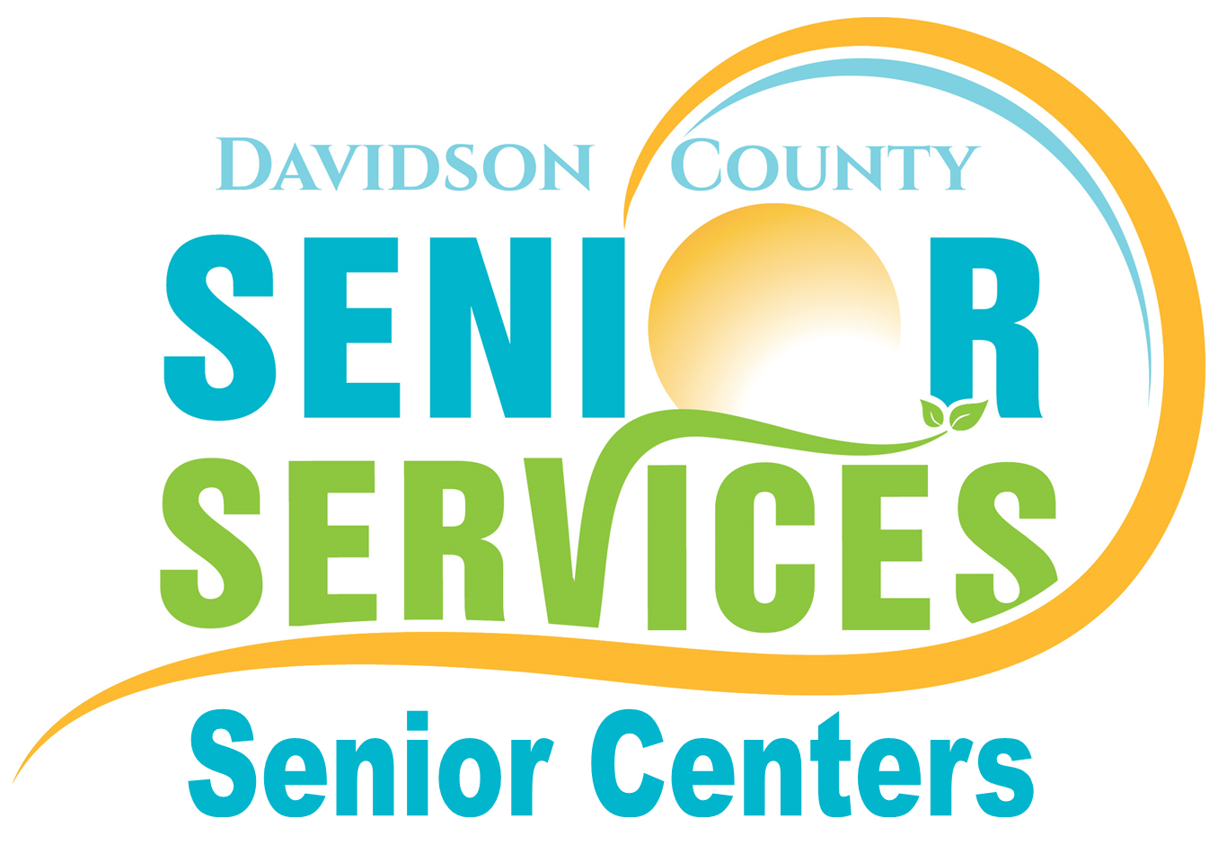

Davidson County Department of Senior Services – Senior Centers
“Centers of Excellence”
NON-PARTICIPANT SURVEY 2016

This survey has been designed by the Davidson County Senior Centers for planning purposes. Information collected will be used to identify activity interests among older adults in Davidson County.

Please check the appropriate box:
Gender: Female Male

Age Range: 55-59 60-64 65-69 70-74
75-79 80-84 85-89 90 & Over

Are you: Retired, not working Retired and working Still working

Do you drive? Yes Yes, but not after dark No

What are the reasons that you don’t visit the Lexington or Thomasville Senior Centers? (you may check more than one)
I do not know much about it I do not know where it is
I do not have transportation I cannot come during hours of operation (8am-5pm)
I do not think anything there would interest me I am too busy

Other reasons (please write here) ___________________________________________________________

Please note any program offerings that you would consider attending at the Centers:
Fitness Center (currently available) Financial Planning
Social Events/Parties Arts & Crafts (currently available)
Health & Wellness Classes (currently available) Brain Fitness
Educational/Technology Classes (currently available) Cooking/Baking Classes

Fill in the information below only if you want to learn more about our programs or apply for services to older adults. If you prefer not to submit your name & contact information, you may also call us at:

Lexington Senior Center – (336) 242-2290 Thomasville Senior Center – (336) 474-2754

I would like to talk someone about Senior Center Activities and Events.
I would like to talk to someone about services such as Meals on Wheels, In Home Aid, Transportation, etc.
Please add me to the email list. My email is: ___________________________________________________

Name: _____________________________________ Phone: ___________________________________

